

**ระบบแจ้งเตือนและตัดการทำงานของปั๊มน้ำโดยใช้เทคโนโลยี**

**อินเทอร์เน็ตในทุกสิ่ง**

**A notification and shutdown system for water pumps using**

**Internet of Things (IoT) technology**

จัดทำโดย

นายธรรมนิตย์ หนูยิ้มซ้าย ชั้นมัธยมศึกษาปีที่ 5

นายชยุต สรรพขาว ชั้นมัธยมศึกษาปีที่ 5

โรงเรียนวิทยาศาสตร์จุฬาภรณราชวิทยาลัย นครศรีธรรมราช

รายงานฉบับนี้เป็นส่วนหนึ่งของรายวิชาโครงงานวิทยาศาสตร์ ว30281 ปีการศึกษา 2566

**ระบบแจ้งเตือนและตัดการทำงานของปั๊มน้ำโดยใช้เทคโนโลยี**

**อินเทอร์เน็ตในทุกสิ่ง**

**A notification and shutdown system for water pumps using**

**Internet of Things (IoT) technology**

จัดทำโดย

นายธรรมนิตย์ หนูยิ้มซ้าย ชั้นมัธยมศึกษาปีที่ 5

นายชยุต สรรพขาว ชั้นมัธยมศึกษาปีที่ 5

อาจารย์ที่ปรึกษา

นาย ฐปนวัฒน์ ชูกลิ่น

โรงเรียนวิทยาศาสตร์จุฬาภรณราชวิทยาลัย นครศรีธรรมราช

รายงานฉบับนี้เป็นส่วนหนึ่งของรายวิชาโครงงานวิทยาศาสตร์ ว30281 ปีการศึกษา 2566

**ชื่อโครงงาน (ไทย) :** ระบบแจ้งเตือนและตัดการทำงานของปั๊มน้ำโดยใช้เทคโนโลยีอินเทอร์เน็ตในทุกสิ่ง

**ชื่อโครงงาน (อังกฤษ) :** A notification and shutdown system for water pumps using Internet of Things (IoT) technology.

**โครงงานสาขา :** วิทยาการคอมพิวเตอร์

**ผู้เขียน :** นายธรรมนิตย์ หนูยิ้มซ้าย ชั้นมัธยมศึกษาปีที่ 504 เลขที่ 5

นายชยุต สรรพขาว ชั้นมัธยมศึกษาปีที่ 504 เลขที่ 2

คณะกรรมการที่ปรึกษา คณะกรรมการสอบ

…………………………………………ประธานครูที่ปรึกษา ………………………………………………..ประธานกรรมการ

(……………………………………….) (………………………………………………)

…………………………………………ครูที่ปรึกษาร่วม ………………………………………………..กรรมการ

(……………………………………….) (………………………………………………)

………………………………………………..กรรมการ

(………………………………………………)

………………………………………………..กรรมการ

(………………………………………………)

คณะกรรมการสอบโครงงานวิทยาศาสตร์ โรงเรียนวิทยาศาสตร์จุฬาภรณราชวิทยาลัย นครศรีธรรมราช อนุมัติฉบับนี้เป็นส่วนหนึ่งของการศึกษา ตามหลักสูตรโรงเรียนวิทยาศาสตร์จุฬาภรณราชวิทยาลัย พุทธศักราช 2566

………………………………………………..

(..……………………………………………………….)

หัวหน้ากลุ่มสาระการเรียนรู้วิทยาศาสตร์และเทคโนโลยี

**ชื่อโครงงาน (ไทย) :** ระบบแจ้งเตือนและตัดการทำงานของปั๊มน้ำโดยใช้เทคโนโลยีอินเทอร์เน็ตในทุกสิ่ง

**ชื่อโครงงาน (อังกฤษ) :** A notification and shutdown system for water pumps using Internet of Things (IoT) technology.

**โครงงานสาขา :** วิทยาการคอมพิวเตอร์

**ปีการศึกษา :** 2566

**ผู้เขียน :** นายธรรมนิตย์ หนูยิ้มซ้าย ชั้นมัธยมศึกษาปีที่ 504 เลขที่ 5

นายชยุต สรรพขาว ชั้นมัธยมศึกษาปีที่ 504 เลขที่ 2

# Abstract

This project presents a water pump monitoring and automatic shutdown system utilizing Internet of Things (IoT) technology to prevent potential damage caused by pump malfunctions, such as dry run conditions or excessive power consumption. The system detects the pump’s status through a flow switch sensor and a PZEM-004T power measurement sensor, sending real-time alerts to users via the LINE application. Additionally, it can automatically shut down the pump when abnormalities are detected.

The system is designed with configurable settings, including pump shutdown delay, power consumption limits, and a protection mode (Protect Mode), all accessible through a user-friendly interface. Real-time notifications enable users to monitor and control the pump remotely. Testing results indicate that the system effectively reduces the risk of pump damage, minimizes maintenance costs, and enhances water management efficiency.

This project can be applied to water pump systems in households, agriculture, and industrial sectors, improving safety and optimizing water usage.

**Keywords :** Internet of Things (IoT), Alert System, Automatic Shutdown, Dry Run, LINE, Blynk, Flow Switch Sensor, Power Measurement Sensor.

**Acknowledgements**

This project was made possible through the generous support of many individuals and would not have been successfully completed without the contributions of each person involved.We would like to express our heartfelt gratitude to Ms. Kusolin Thipmanosingh, a Computer Science teacher at Princess Chulabhorn Science High School Nakhon Si Thammarat, and Mr. Thapanawat Chooklin, our project advisor, for providing continuous guidance on the project, assisting with the use of equipment and tools, and offering support in the form of food, beverages, and constant encouragement throughout the development process.

We would also like to sincerely thank Mr. Wichai Rajtanee, the principal of Princess Chulabhorn Science High School Nakhon Si Thammarat, along with all the teachers and staff members, for their unwavering support, encouragement, and facilitation throughout the process. Their contributions greatly helped bring this project to a successful completion.

We would also like to thank our friends, seniors, and juniors at Princess Chulabhorn Science High School Nakhon Si Thammarat for being a vital source of encouragement that helped us carry this project through to completion. Their ongoing support, guidance, and helpful suggestions have been invaluable throughout the process.If there are any mistakes or shortcomings in this project, we sincerely apologize.

Project Team

Mr.Thammanit Nooyimsai

Mr.Chayut Sapphakhao

# สารบัญ

บทคัดย่อ ข

Abstract ค

กิตติกรรมประกาศ ง

สารบัญ จ

สารบัญภาพ ช

บทที่ 1 บทนำ 1

ที่มาและความสำคัญ 1

วัตถุประสงค์ 1

ขอบเขตของการศึกษา 1

สมมติฐาน 1

ตัวแปรที่ศึกษา 1

นิยามเชิงปฏิบัติการ 1

บทที่ 2 ทฤษฎีและงานวิจัยที่เกี่ยวข้อง 2

ทฤษฎีเกี่ยวกับเซ็นเซอร์ตรวจจับการไหลของน้ำ (Flow Switch) 2

ทฤษฎีเกี่ยวกับ Node MCU ESP8266 2

ทฤษฎีเกี่ยวกับจอแสดงผล LCD 3

ทฤษฎีเกี่ยวกับบอร์ด Relay 12 VDC 220 VAC 2 ช่องสัญญาณ 4

ทฤษฎีเกี่ยวกับปั๊มน้ำ 5

ทฤษฎีโปรแกรมภาษา C สำหรับ Arduino 6

ทฤษฎีเกี่ยวกับแอปพลิเคชัน Blynk 6

ทฤษฎีเกี่ยวกับ Router 6

ทฤษฎีเกี่ยวกับ Application Line 7

งานวิจัยที่เกี่ยวข้อง 8

บทที่ 3 วิธีดำเนินการทดลอง 10

วัสดุอุปกรณ์สำหรับสร้างระบบ 10

เครื่องมือสำหรับจัดทำโครงงาน 10

โครงสร้างระบบทางด้านฮาร์ดแวร์ 10

ผังงานขั้นตอนการทำงานของระบบ 12

การดำเนินงานและการทดลอง 14

การติดตั้งระบบ 14

บทที่ 4 ผลการดำเนินงาน 15

การออกแบบฮาร์ดแวร์ 15

การออกแบบซอฟต์แวร์ 15

ผลการทดลอง 18

บทที่ 5 สรุปการดำเนินงาน 19

สรุปผล 19

อุปสรรคและปัญหา 19

แนวทางการแก้ไขปัญหา 19

ข้อเสนอแนะ 20

บรรณานุกรม 22

# สารบัญภาพ

ภาพที่ 1 เซ็นเซอร์วัดการไหลของน้ำ (FLOW SWITCH) 2

ภาพที่ 2 ลักษณะของ NODE MCU ESP8266 3

ภาพที่ 3 จอ LCD ขนาด 20x4 3

ภาพที่ 4 แสดงการเชื่อมต่อสายสัญญาณ 4

ภาพที่ 5 ตัวอย่าง CODE สำหรับบอร์ด ESP8266 แสดงผลที่จอ LCD 4

ภาพที่ 6 ลักษณะของรีเลย์ 2 ช่อง 5

ภาพที่ 7 ปั๊มน้ำหอยโข่ง 5

ภาพที่ 8 แอปพลิเคชัน BLYNK 6

ภาพที่ 9 ROUTER สำหรับเชื่อมต่อเครือข่ายและกระจายสัญญาณอินเทอร์เน็ต 7

ภาพที่ 10 APPLICATION LINE สำหรับแจ้งเตือนการทำงาน 7

ภาพที่ 11 แสดงแผนผังการเชื่อมโยงระหว่างผู้ใช้ระบบกับแปลงสวนสละ 8

ภาพที่ 12 แสดงโครงสร้างระบบของระบบให้น้ำสวนสละ 9

ภาพที่ 13 โครงสร้างระบบควบคุมอุปกรณ์ไฟฟ้า 9

ภาพที่ 14 โครงสร้างระบบทางด้านฮาร์ดแวร์ 11

ภาพที่ 15 ผังงานขั้นตอนการทำงานของระบบ 12

ภาพที่ 16 ผังงานขั้นตอนการทำงานของระบบ(ต่อ) 13

ภาพที่ 17 ด้านหน้าของอุปกรณ์ 15

ภาพที่ 18 INTERFACE ผู้ใช้งานใน APLLICATION BLYNK 16

ภาพที่ 19 ด้านหน้าของอุปกรณ์ 16

**Chapter 1 Introduction**

**Background and Significance**

## Water pumps are essential devices used in both household and agricultural sectors. A major problem often encountered is the "Dry Run" condition, where the pump operates without water flow. This can cause damage to the pump and lead to unnecessary electricity consumption.This project aims to develop a notification and shutdown system for water pumps using IoT (Internet of Things) technology to prevent damage and reduce maintenance costs.

## Objectives

* To develop a notification and protection system against abnormal water pump operation.
* To prevent damage to the water pump.
* To collect operational data from the pump for further analysis.

## Scope of the Study

* The water pump must have a minimum power rating of 1 horsepower.
* The water outlet pipe must be at least 1 inch in diameter.
* The pump must use AC power at 220 volts.
* Pump abnormalities are detected based on two main factors:

1. Water flow detection using a Flow Switch
2. Power consumption detection using the PZEM-004T, measured in amperes

* The main processing board used is the NodeMCU ESP8266.
* The system is monitored and controlled via the Blynk Legacy application.
* Notifications from the system are sent to users through a LINE group application.

## Hypothesis

The system will send alerts and automatically shut down the pump when it operates without water flow or when it exceeds the predefined power usage limit, effectively preventing pump damage.

**Variables**

Independent Variable The water pump monitoring system

Dependent Variable The operational performance of the pump

Controlled Variable The environmental conditions in which the pump operates

## Operational Definitions

Notification and Shutdown System for Water Pumps refers to a system that can detect abnormal pump behavior such as failure to draw or push water, or unusually high power consumption and send alerts to users while automatically shutting off the pump to prevent damage, such as motor burnout.

Pump Performance refers to the pump’s ability to operate within expected capacity, delivering water within a specific time frame using standard electrical power, measured by the volume of water pumped over time.

Pump Operating Conditions refer to the environmental settings under which the pump operates, such as room temperature conditions.

# Chapter 2 Theories and Related Research

This chapter presents the theories and prior research that form the foundation for developing the notification and shutdown system for water pumps using Internet of Things (IoT) technology. To build such a system, the project team studied multiple components and concepts, which were then applied to achieve the desired objectives.

The following topics were explored:

1. Theory of Flow Switch (Water Flow Detection Sensor)
2. Theory of NodeMCU ESP8266
3. Theory of LED Display
4. Theory of Relay Board 12 VDC 220 VAC, Dual Channel
5. Theory of Water Pumps
6. Theory of C Programming for Arduino
7. Theory of Blynk Application
8. Theory of WiFi Router
9. Theory of LINE Application
10. Related Research

## Theory of Flow Switch (Water Flow Detection Sensor)

A flow switch is a device used to control the operation of various electrical equipment, such as water pumps. It works by using the movement of water or liquid to spin a paddle connected to the switch, which then moves according to the direction of flow. This movement triggers the switch to turn on or off the electrical circuit powering the equipment.The switching mechanism can be adjusted based on the rate of water flow, and paddles come in various lengths to suit different system requirements. An illustration of this component is shown in Figure 1.

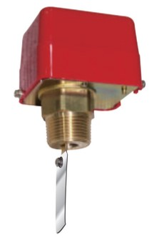

Figure 1 Water Flow Sensor (Flow Switch)

Source : <https://acezphil.com/product/ecofs50p/>

## Theory of NodeMCU ESP8266

The NodeMCU Development Kit V1.0 is an improved version of NodeMCU Version 0.9. It is a module that includes the ESP8266-12E chip and features a PCB antenna. The module provides pin headers for various signal interfaces, including GPIO, PWM, I2C, 1-wire, ADC, and an enhanced SPI interface compared to the previous version.It also includes a USB-to-TTL interface and a micro USB port, utilizing the Silicon Labs CP2102 USB-to-Serial chip for easy connection to a computer for programming.The NodeMCU can be flashed with NodeMCU firmware and is compact in size, making it suitable for use with a breadboard.An illustration is shown in Figure 2.

Figure 2 Characteristics of the NodeMCU ESP8266  
Source : <https://techtalk2apply.com/what-is-esp8266/>

From Figure 2, users can choose to develop using LUA scripts with NodeMCU firmware or use the ESP8266 module as a development kit that can be programmed using the Arduino IDE. The module provides access to up to 10 GPIO pins, which can be used to develop Internet of Things (IoT) projects, allowing connection to various external devices as needed.

## Theory of LCD Display

LCD stands for Liquid Crystal Display, a type of digital screen. The images displayed are created by light emitted from a backlight, which passes through a polarized filter layer and then through liquid crystal cells arranged in three sub-pixels red, green, and blue which together form bright, visible pixels.An example is shown in Figure 3.

Figure 3 20x4 LCD Display  
Source : <http://www.arduino.in.th/p/102/>

From Figure 3, the LCD shown uses an I2C (Inter-Integrated Circuit) connection, also known as a serial connection. It is a standard LCD module paired with an I2C interface board, making it more convenient to use. The module also includes a variable resistor (VR) for adjusting the screen brightness.In I2C mode, only 4 pins are required to connect the LCD to a microcontroller, compared to 16 pins in parallel mode, making the setup much simpler and more efficient.The connection between the signal pins and the ESP8266 board is illustrated in Figure 4.

Figure 4 Signal Wiring Connection Diagram  
Source : <https://newbiely.com/tutorials/esp8266/esp8266-lcd-20x4/>

From Figure 4, it can be seen that only four wires are required for the connection. The signal pins used for data communication between the ESP8266 board and the LCD display are SDA and SCL. These are connected to pins D2 and D1 on the ESP8266 board.An example of the C code used to control the LCD and display desired information is shown in Figure 5.

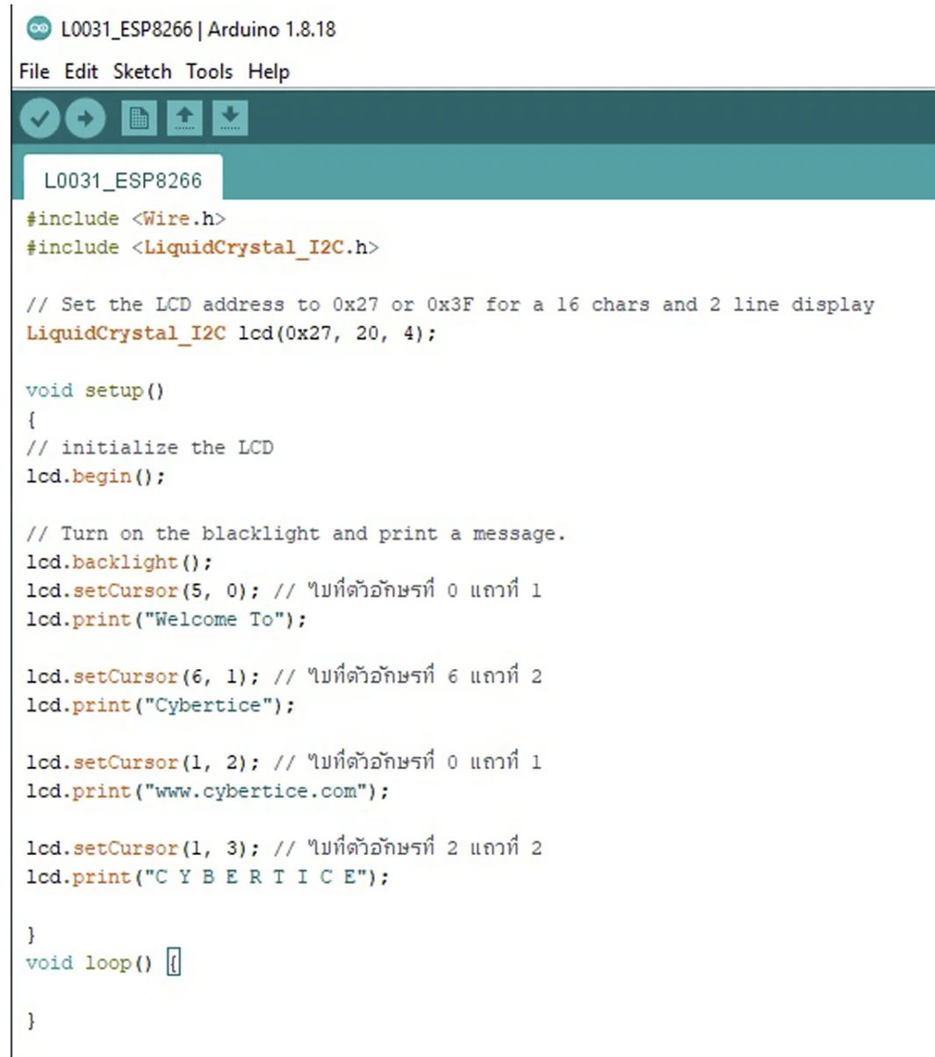

Figure 5 Example Code for ESP8266 Board Displaying Output on LCD  
Source : <https://www.cybertice.com/article/719/>

From Figure 5, this is an example of code written for the ESP8266 board that displays four lines of text on the LCD screen. It includes the use of the LiquidCrystal_I2C.h library, which enables the code to function properly.

## Theory of 12 VDC 220 VAC Dual-Channel Relay Board

The relay used in this project is designed to connect to the output of PLCs or other devices (whether PNP or NPN type) to control external circuits through its contact relays.This relay board is compact, easy to maintain, and portable, with an aesthetic design suitable for installation on DIN rails in electrical enclosures.It also features LED indicators to show the current operating status and supports wiring of up to 2.5mm². It can operate within temperatures of 0–50°C.An illustration is shown in Figure 6.

Figure 6 Characteristics of Dual-Channel Relay Module  
Source : <https://www.genlogic.co.th/product/53/>

From Figure 6, the relay module is a device that converts electrical energy into magnetic energy. This magnetic force is used to attract the relay contacts, changing their state by supplying current to a coil, which acts to open or close the contacts, much like an electronic switch.Relays can be applied in various electronic circuit control systems, making them widely used in electrical and electronics projects.

## Theory of Water Pumps

Centrifugal water pumps are widely used, especially in agricultural applications, due to their ability to pump large volumes of water. The water does not need to be clean, as impurities mixed in the water have little effect on this type of pump.These pumps are commonly used in fields, vegetable gardens, orchards, and even in livestock farms. They are ideal for pumping water from rivers, streams, ponds, canals, or reservoirs where the water level is no more than 10 meters below ground level.An example is shown in Figure 7.

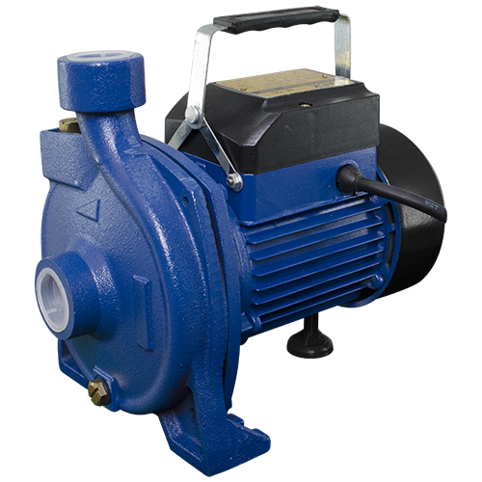

Figure 7 Centrifugal Water Pump  
Source : <https://www.nakashithailand.com/en/product/32972-48703/>

From Figure 7, a centrifugal water pump operates using four main components

1. Impeller :Generates centrifugal force to push the water inside the pump housing.

2. Casing :Converts the centrifugal force from the impeller into effective water pressure.

3. Suction Port :Serves as the inlet pipe that draws water into the pump.

4. Discharge Port :Functions as the outlet pipe that releases the water from the pump.

## Theory of C Programming for Arduino

C language is a fundamental programming language widely used in various fields such as computer operating systems, mathematical software, electronics, and microcontroller programming. It allows users to input C code for complex calculations or signal processing, enhancing system performance.C is often referred to as a mid-level language, as it bridges the gap between low-level languages like Assembly and high-level languages like COBOL, FORTRAN, or Pascal. It offers flexible pointer management and, in many cases, allows developers to control hardware directly, almost as if writing in Assembly.

Arduino IDE is a platform designed for hardware-based development, providing an interface for programming and connecting to hardware I/O. It supports various types of communication and hardware modules that can be integrated into diverse projects.

## Theory of Blynk Application

Blynk platform is designed for controlling Internet of Things (IoT) devices. It offers remote control via the internet and can also display real-time data values.This is illustrated in Figure 8.



Figure 8 Blynk Application Interface  
Source : <https://doc.inex.co.th/mbit-with-microblockide-ep8/>

From Figure 8, Blynk is a ready-to-use application for IoT projects. One of its key features is the simplicity of programming—users don’t need to build a mobile app from scratch. It operates in real-time and allows easy connection of devices to the internet, such as ESP8266, ESP32, and Raspberry Pi. These devices can be integrated and monitored through the application with ease.Most importantly, Blynk is free and compatible with both iOS and Android operating systems.

## Theory of Routers

A router is a device used to connect to a network or the internet. Its primary function is to determine the data transmission path and act as a gateway, forwarding data to other networks. It also shares internet connections with computers and client devices.An example of a router is shown in Figure 9.

Figure 9 Router for Network Connection and Internet Signal Distribution  
Source : <https://www.tp-link.com/th/home-networking/3g-4g-router/archer-mr400/>

From Figure 9, the router includes ports called LAN Ports (RJ-45), typically offering four ports (with speeds of 10/100 Mbps) or more. It also features an Internet Port or WAN Port (RJ-45) used to connect to an ADSL modem or fiber media converter, allowing the router to access the internet.When purchasing a router, it is generally recommended to choose one with at least four LAN ports, so it can connect multiple wired devices such as desktop PCs, printers, or other network-enabled equipment.

## Theory of the LINE Application

The LINE application is a communication tool that allows users to chat, send messages, share files, create group conversations, and even make voice calls over the internet. It is available on mobile devices such as smartphones and tablets, and it can also be installed and used on regular desktop computers.

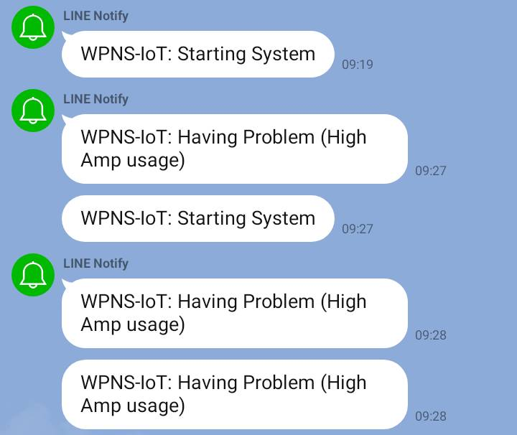

Figure 10: LINE Application for System Notification Alerts

From Figure 10, the image illustrates the use of the LINE application for system notifications, alerting users about the operational status of the system and sending warnings when a device encounters a problem or malfunction.

### ****Related Research****

1. Online Automatic Irrigation Control System for Salacca GardensThis research, conducted by Mr. Watcharin Krainara and team, developed an online automatic system to control irrigation in salacca gardens. The system could be controlled in two ways: via a keypad on the control panel and online through the Blynk application.It supported three operation modes: automatic watering based on soil moisture, watering based on a set time, and manual control by the user.The researchers also designed the system so the water pump would operate automatically based on the solenoid valve’s open-close state, without needing separate control of the pump, making it more convenient. Additionally, the system included a protection mechanism for the pump.

The system design used an Arduino Mega 2560 microcontroller as the main processor and an Ethernet Shield W5100 for internet connectivity. Key inputs included four soil moisture sensors and a water flow sensor, while key outputs included four solenoid valves and a water pump.

During testing, the control cabinet was installed near the pump station in the salacca garden, and solenoid valves were installed in parallel with the existing valves to serve as a backup.The results showed that the system could receive commands correctly both from the keypad and via the Blynk app. It was able to operate under all three modes as expected.Additionally, if the pump encountered a problem, the system could stop the pump and send an alert message to users via the LINE application.A diagram showing the relationship between the system and its users is shown in Figure 11.

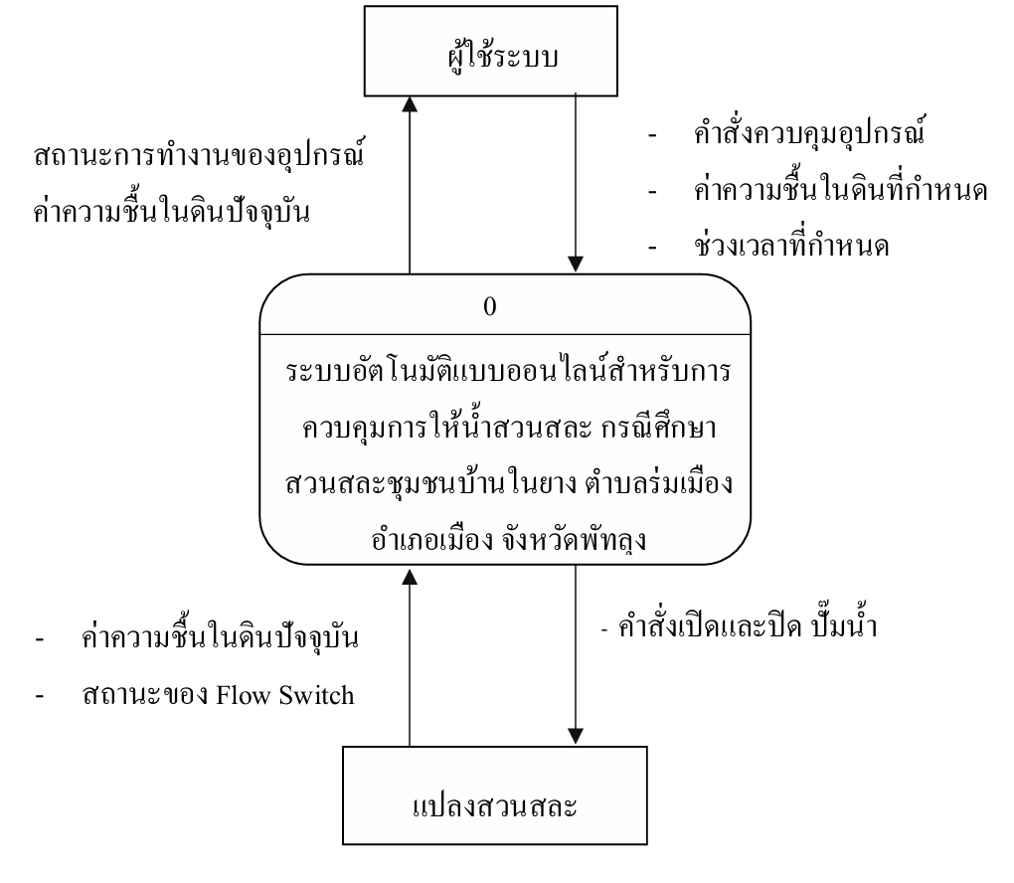

Figure 11 Diagram Showing the Connection Between System Users and the Salacca Garden

From Figure 11, the diagram illustrates the relationship between the system users and the control system, which allows users to manage the pump's operation based on scheduled timing and real-time soil moisture readings.The system architecture of this research is shown in Figure 12.

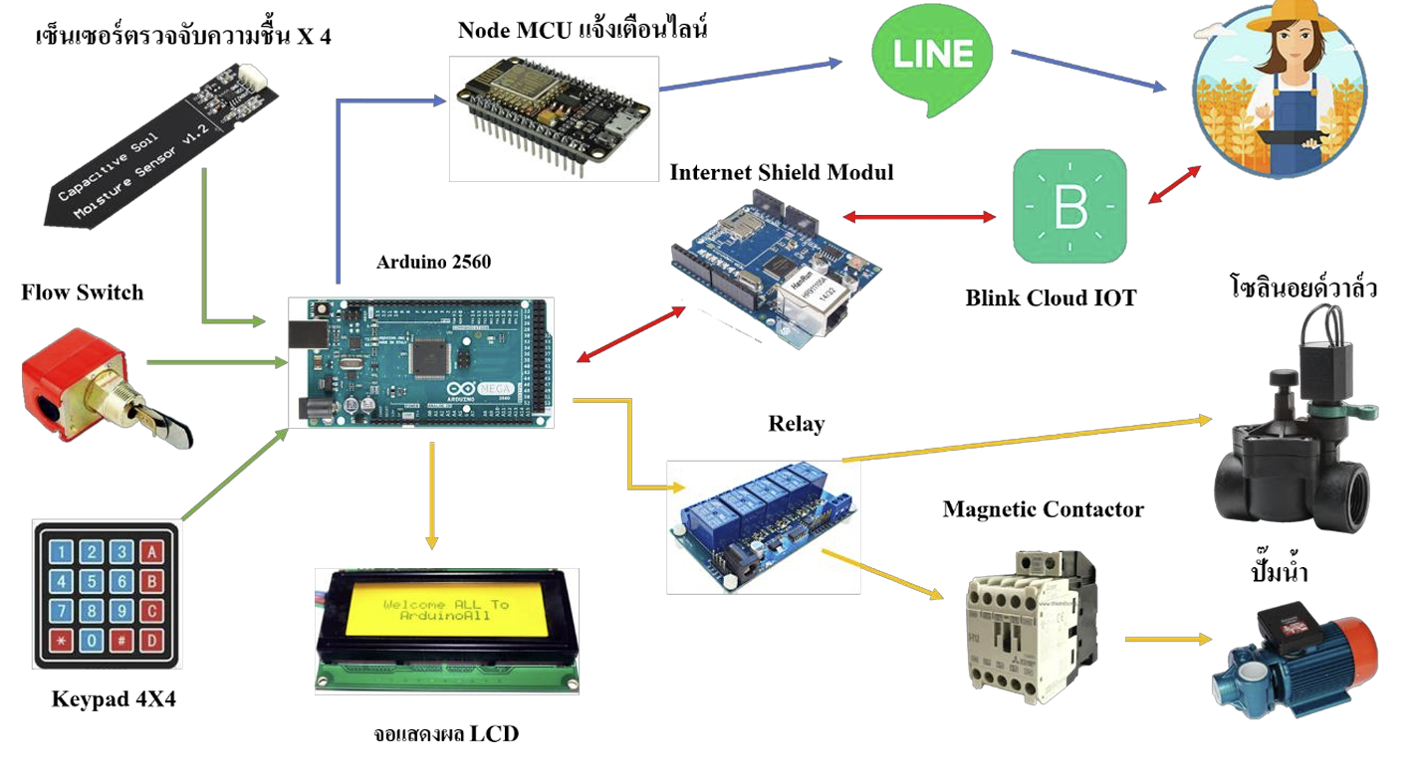

Figure 12: System Architecture of the Salacca Garden Irrigation System

1. Research on an Online Automatic System for Controlling Electrical Devices for Energy SavingThis research involves the development of an online automatic system designed to control electrical appliances for the purpose of energy conservation. The system can be operated in two ways: directly at the control cabinet using a keypad, and remotely via the Blynk application.The system offers two modes of operation: 1. Automatic mode, in which the system functions on its own based on the user’s predefined preferences. 2. Manual mode, allowing users to switch devices on or off as desired. The researchers implemented an Arduino ATmega2560 microcontroller in combination with a NodeMCU ESP8266 board for internet connectivity. A magnetic switch was used to control the power state of the system.

The results showed that the online automatic system effectively reduced power consumption, helped monitor electrical device usage, and simplified the control of turning devices on or off.The system architecture of this research is illustrated in Figure 13.

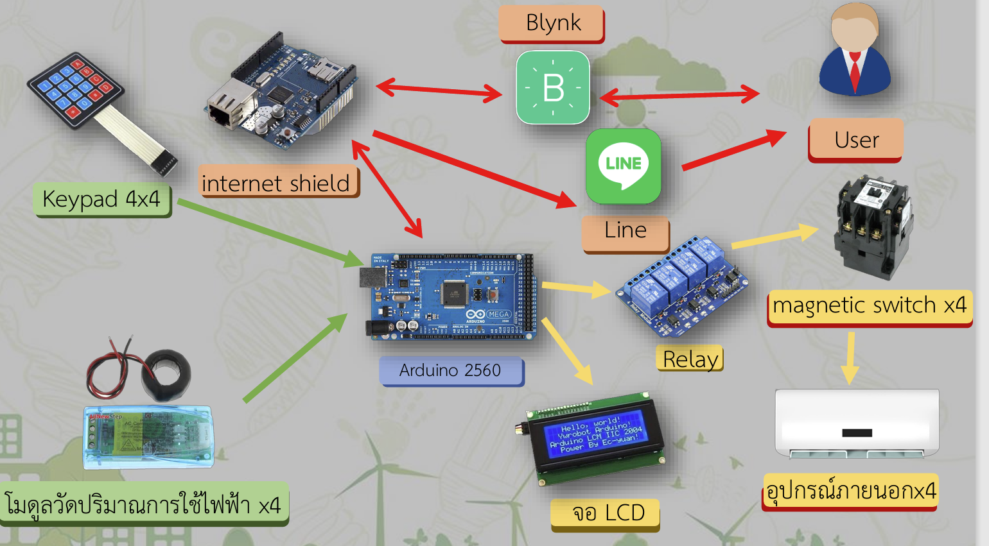

# Figure 13: System Architecture for Electrical Device Control

# Chapter 3: Experimental Procedures

In this science project titled “A Notification and Shutdown System for Water Pumps Using IoT Technology”, the team designed the experimental procedures to ensure the system functions according to the defined objectives. The procedures and components are detailed as follows:

### ****Materials and Equipment for System Development****

## Centrifugal water pump, 1 HP 1 unit

## 100-liter plastic water tank for recirculating system 1 unit

## ESP-8266 microcontroller board 1 board

## Socket for ESP-8266 board 1 unit

## Flow switch for detecting water flow in the pipe 1 unit

## AC power consumption monitoring module 1 unit

## LCD display, size 20 x 4 1 unit

## Hi-Link power module (converts 220V AC to 5V DC) 2 units

## 2-channel relay module 1 unit

## 8-port terminal block 1 unit

## Pilot lamps for status indication 2 units

## Double-throw switch 1 unit

## Plastic enclosure box 1 unit

## SIM-based modem router 1 unit

## Mobile SIM card with internet connection 1 SIM

## Miscellaneous (PVC pipes, electrical wires, signal cables, zip ties, etc.)

### ****Tools for Project Implementation****

1. Computer for programming and documentation 1 unit
2. Android smartphone 1 unit
3. C programming software for Arduino boards
4. Blynk Legacy application
5. LINE application

## Hardware System Architecture

The hardware system architecture is illustrated in Figure 14.

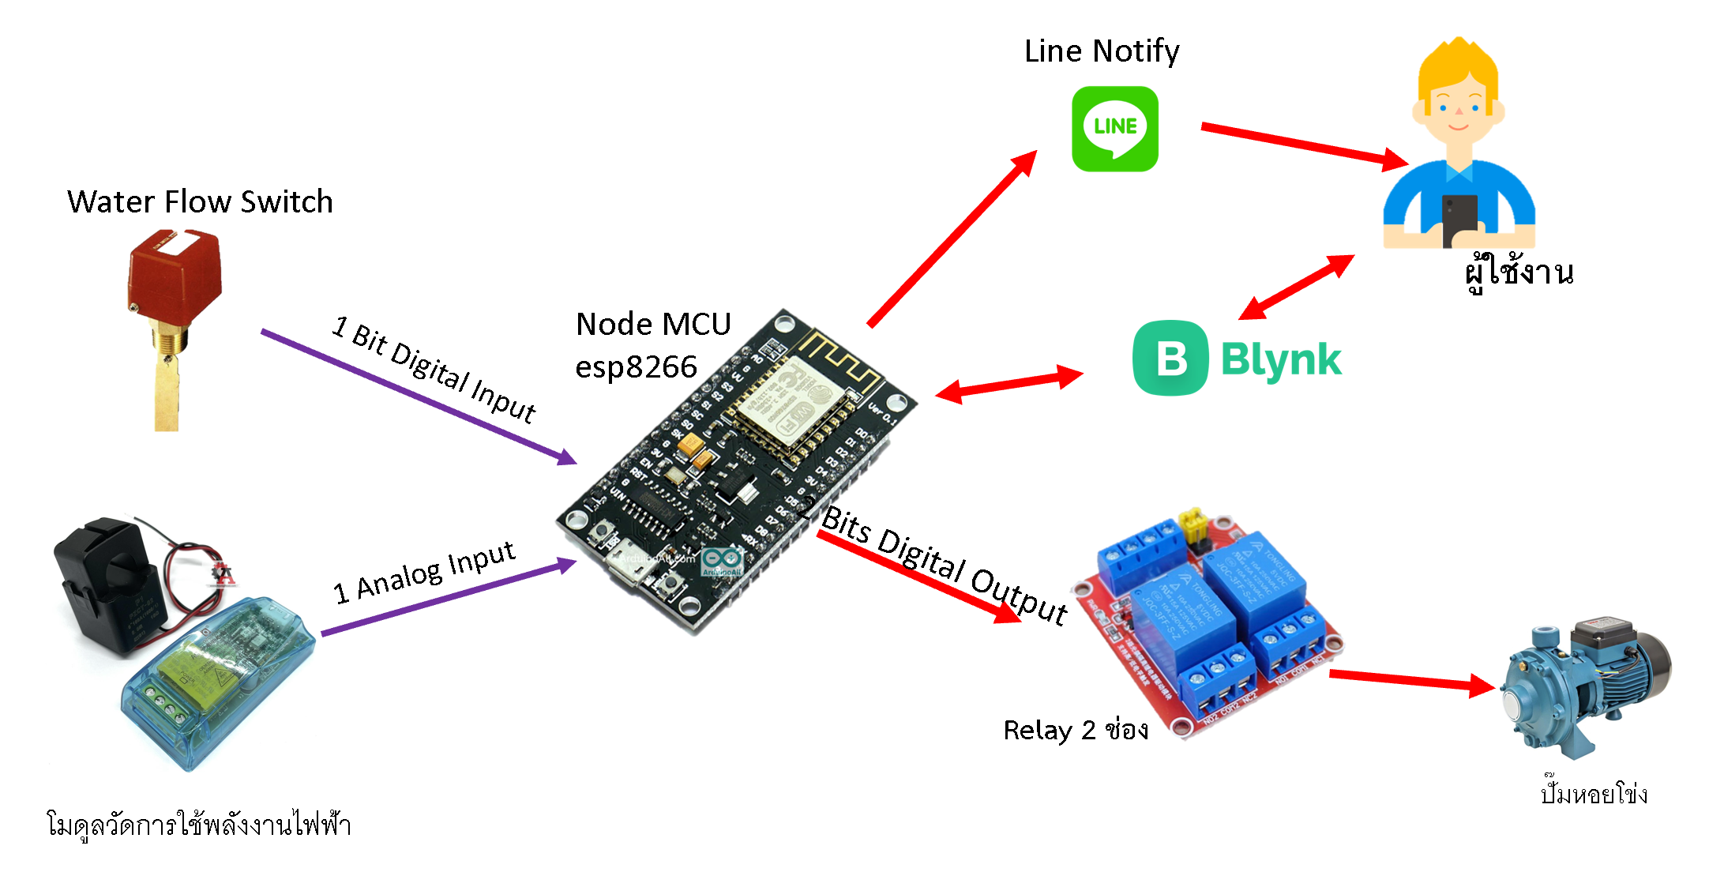

Figure 14 Hardware System Architecture

## System Workflow Diagram

The system’s workflow diagram is illustrated in Figures 15–16.

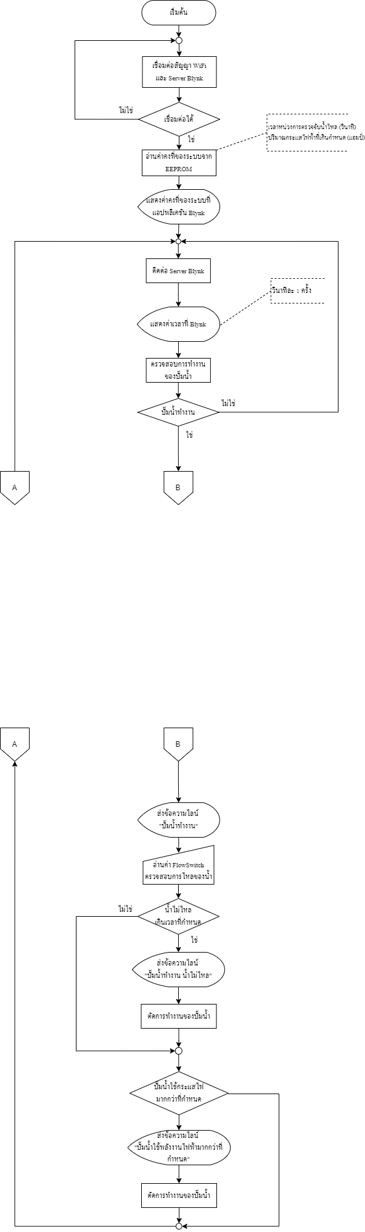Figure 15 System Workflow Diagram

Figure 16 System Workflow Diagram (Continued)

## Implementation and Experimentation

* + 1. Studied and tested the functionality of the water pump
    2. Installed C programming software for Arduino board
    3. Wrote and tested a basic program to control the ESP8266 board
    4. Studied and tested the operation of the Flow Switch
    5. Programmed the ESP8266 to detect the Flow Switch status
    6. Studied and tested the power monitoring module
    7. Programmed the ESP8266 to monitor power usage
    8. Programmed ESP8266 to connect with the Blynk application
    9. Programmed ESP8266 to connect with the LINE application
    10. Programmed the logic for pump shutdown and alert conditions
    11. Tested the complete system functionality
    12. Assembled all components into the plastic enclosure
    13. Installed pilot lamp and switch on the front panel of the plastic box
    14. Conducted system testing after full assembly

## System Installation

1. Installed the Flow Switch onto the pump’s water outlet pipe
2. Installed the plastic enclosure near the water pump control cabinet
3. Connected the power supply to the notification system
4. Connected the Flow Switch signal wire to the terminal inside the control cabinet
5. Connected the relay signal wire to enable automatic shutdown of the pump
6. Configured WiFi settings for the alert system

# Chapter 4 Results of Implementation

This chapter presents the development and testing of the system to ensure it operates as specified within the defined scope.

## Hardware Design

Based on the analysis of the system within the project's defined scope, the hardware was designed using the ESP8266 as the central processor. The inputs connected to the system include the Flow Switch and PZEM-004T. The Flow Switch detects whether water is flowing, and the PZEM-004T measures the pump’s power consumption. This data is sent to the ESP8266 for processing to determine whether usage exceeds the threshold. A 4x4 keypad is used for user input settings, and an LCD display serves as the output interface, as shown in Figure 17.

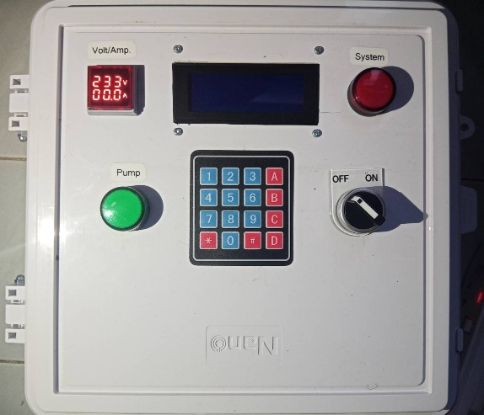

Figure 17 Front View of the Device

From Figure 17, the project developers designed and integrated the hardware components. The ESP8266 board receives input from the PZEM-004T, Flow Switch, and 4x4 Keypad. The keypad allows users to define operational criteria and customize pump protection settings as needed. The system also sends notifications whenever there is a change in the pump status or system state.

### ****Software Design****

1. Data Display via Blynk Legacy

This interface is used to control the notification and automatic shutdown system for the water pump through the Blynk Legacy application. It displays information such as pump status, system status, time, power consumption, and shutdown delay settings, as shown in Figure 18.

1. System Output Display via LCD Screen

The LCD screen displays real-time electrical current usage, as shown in Figure 19.

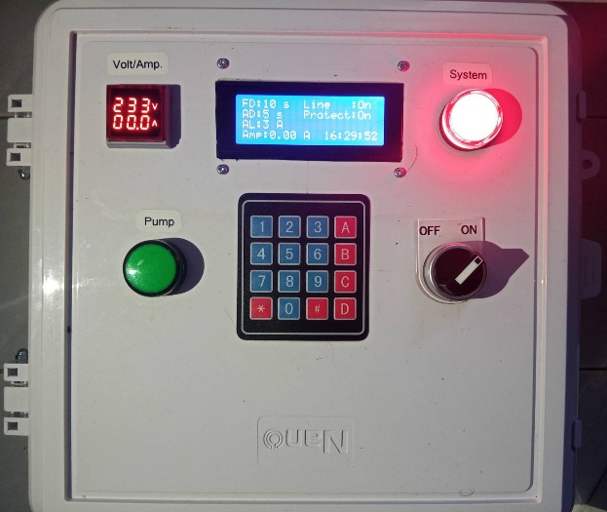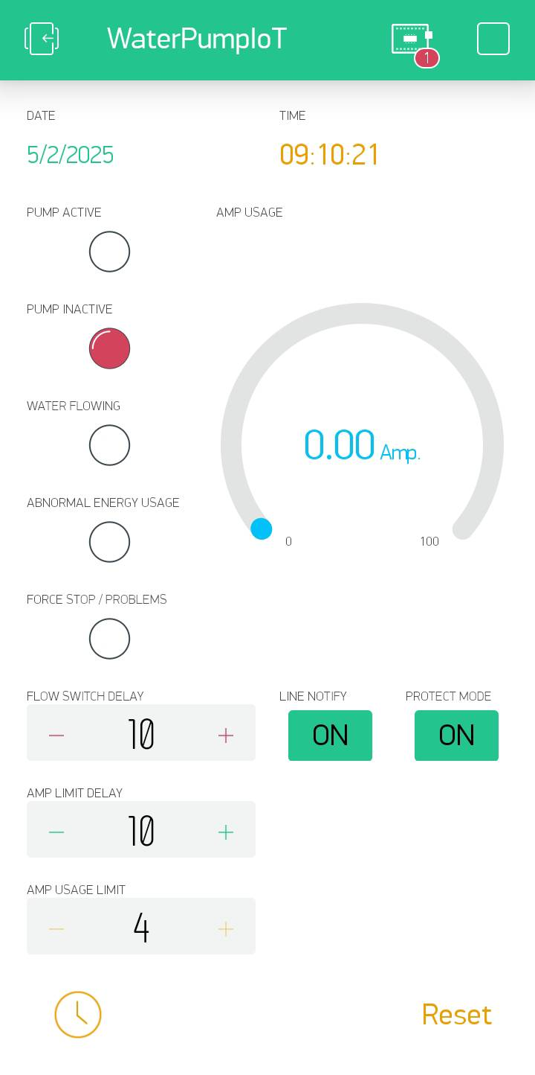 From Figure 18, the system interface displayed through the Blynk application allows users to monitor and configure the pump system. Key components include:

Figure 18 User Interface in the Blynk Application

Figure 19 Front View of the Device

1. **DATE :** Displays the current date, useful for tracking system events.
2. **TIME :** Displays the current time, synchronized with Blynk’s server for accuracy.
3. **PUMP ACTIVE :** Green LED that lights up when the pump is running, measured via PZEM-004T.
4. **PUMP INACTIVE :** Red LED that lights up when the pump is off, measured via PZEM-004T.
5. **WATER FLOWING :** Blue LED that lights up when the Flow Switch detects water flow.
6. **ABNORMAL ENERGY USAGE :** Orange LED that lights up when the pump exceeds the power threshold.
7. **FORCE STOP / PROBLEMS :** Red LED that lights up in case of emergency stop or detected issue.
8. **AMP USAGE :** เ Digital gauge showing current usage in amps.
9. **FLOW SWITCH DELAY** **:** Numeric input to set delay time (seconds) before shutting down due to no water flow.
10. **AMP LIMIT DELAY** **:** Numeric input to set delay time before shutdown due to overcurrent.
11. **AMP USAGE LIMIT (จำกัดการใช้กระแสไฟฟ้า)** **:** Input field to set the maximum amp usage; if exceeded beyond the set delay, the pump shuts off.
12. **LINE NOTIFY (การแจ้งเตือนผ่าน Line)** **:** Boolean input (ON/OFF) to enable or disable notifications via LINE.
13. **PROTECT MODE :** Boolean input to enable/disable the protection mode:

- ON: the system automatically shuts down the pump when a problem occurs.

- OFF: the pump continues running even if an issue is detected.

1. **RTC (Real Time Clock)** **:** Syncs system time with the Blynk server.
2. **RESET :** Button to restart the pump after a shutdown due to a fault or power overuse.

From Figure 19, the LCD display interface is used to monitor and control system settings, with key components including:

1. **FLOW DELAY (FD) :** Delay before shutting down the pump due to no water flow.
2. **AMP DELAY (AD) :** Delay before shutting down the pump due to overcurrent.
3. **AMP LIMIT (AL) :** Max allowable current; if exceeded and persists, the pump shuts off.
4. **AMP :** Real-time amp usage.
5. **Line :** Shows LINE notification status.
6. **Protect :** Displays status of Protect Mode.

Keypad Controls:

* **1, 4 :** Increase/decrease FLOW DELAY
* **2, 5 :** Increase/decrease AMP DELAY
* **3,6 :** Increase/decrease AMP LIMIT
* **\* :** Toggle LINE Notify
* **# :** Toggle Protect Mode

## Test Results

The experiments confirmed that the system operated as intended and was effective in detecting and preventing water pump damage. The results are divided into three key areas:

### Alert Notification Test

**Objective**: To test the accuracy of alerts under abnormal conditions (e.g., Dry Run, power issues).

**Results:**

* If water stops flowing beyond the delay threshold, the "Water Flowing" LED turns off and a LINE Notify alert is sent.
* If current usage exceeds the set limit and delay, the "Abnormal Energy Usage" LED lights up and a warning is sent.
* Emergency stops or detected issues immediately trigger a LINE alert.

### Pump Shutdown Test

**Objective:** To test whether the system can automatically shut down the pump in abnormal situations.

**Results:**

* When water doesn’t flow for too long, the system shuts the pump off and lights the “Pump Inactive” LED.
* When overcurrent is detected, the system cuts off the pump and notifies the user.
* When Protect Mode is ON, the system shuts down automatically. When OFF, the pump continues running despite issues.
* Pressing the RESET button restarts the pump.

### Configuration and Control via Interface Test

**Objective:** To test the system’s responsiveness to user-defined settings through the interface.

**Results:**

* Delay settings (Flow Switch Delay and Amp Limit Delay) are adjustable in real-time and affect system behavior.
* Amp usage limit can be set freely and is effective in preventing overuse.
* LINE Notify and Protect Mode can be toggled and reflected immediately on the interface.
* Real-time status display allows users to monitor pump conditions clearly.

# Chapter 5 Project Summary

This chapter presents a summary of the research findings, experimental results, suggestions, and future improvement directions, based on the problems and experiences encountered during the development process. The details are as follows:

## Summary of Results

From the study and experimentation, the notification and automatic shutdown system for water pumps successfully met its objectives. The system effectively detects abnormal pump conditions, such as Dry Run operation and excessive power consumption, and can alert users via the LINE Notify application. It also automatically shuts down the pump in response to detected issues.

The interface design allows users to easily monitor pump status, adjust delay settings, and define power usage limits. The system functions smoothly with the Flow Switch and PZEM-004T sensors. Moreover, test results show that the system can reduce the risk of pump damage, lower maintenance costs, and enhance the efficiency of water management.

## Obstacles and Challenges

Although the system operated as intended, several issues were encountered during development:

* Notification via LINE Notify and interface control may experience delays or malfunction if internet connectivity is unstable.
* In some cases, the Flow Switch may not accurately detect water flow, especially in systems with low water pressure.
* Determining appropriate current limit values (Amp Usage Limit) required multiple trials to suit different types of pumps.

## Problem-Solving Approaches

To address the challenges encountered, the development team made the following improvements:

* Added a function to handle internet outages, allowing for offline data logging and sending alerts when the internet is restored.
* Replaced the mechanical Flow Switch with a more accurate ultrasonic flow sensor or a Hall Effect Flow Meter, which can detect water flow more reliably, even at low pressure.
* Established standardized values for the Amp Usage Limit by testing various types of pumps to define suitable electrical current thresholds.

## Recommendations

* Develop a dedicated application for the system to improve control capabilities and overcome limitations of the Blynk platform.
* Enable cloud-based logging of pump operation data to allow historical tracking and analysis of performance trends.
* Upgrade the system to monitor and control multiple pumps simultaneously, making it suitable for industrial or large-scale agricultural use.

**References**

# References

นายอิทธิชัย รอดขวัญ, นายพงศ์ฆนา มหาสวัสดิ์ และ นายวัชรินทร์ ไกรนรา. (2562). ระบบอัตโนมัติแบบออนไลน์สำหรับการควบคุมการให้น้ำสวนสละกรณีศึกษาสวนสละชุมชนบ้านในยาง ตำบลร่มเมือง อำเภอเมือง จังหวัดพัทลุง. สาขาวิชาเทคโนโลยีสารสนเทศ คณะวิทยาศาสตร์และเทคโนโลยี : มหาวิทยาลัยเทคโนโลยีราชมงคลศรีวิชัย วิทยาเขตนครศรีธรรมราช ไสใหญ่. (สืบค้นเมื่อ 30 พฤษภาคม 2567).

นางสาวสิริวรรณ จรอนันต์, นางสาวธิดารัตน์ คงสวัสดิ์, นายนนทวัฒน์ จันทร์เสน. (2564). ระบบอัตโนมัติแบบออนไลน์สำหรับควบคุมการเลี้ยงนกหงส์หยกกรณีศึกษาฟาร์มบ้านนกหงส์หยกปากพนัง อำเภอปากพนังจังหวัดนครศรีธรรมราช. สาขาวิชาเทคโนโลยีสารสนเทศ คณะวิทยาศาสตร์และเทคโนโลยี : มหาวิทยาลัยเทคโนโลยีราชมงคลศรีวิชัย วิทยาเขตนครศรีธรรมราช ไสใหญ่. (สืบค้นเมื่อ 30 พฤษภาคม 2567).

Node MCU ESP8266 แหล่งที่มา: [http://www.ayarafun.com/2015/08/introduction-arduino-ESP8266-nodemcu/](http://www.ayarafun.com/2015/08/introduction-arduino-esp8266-nodemcu/) (สืบค้นเมื่อ 30 พฤษภาคม 2567).

Arduino IDE แหล่งที่มา: <https://www.ai-corporation.net/2021/11/18/what-is-arduino-ide/>

(สืบค้นเมื่อ 30 พฤษภาคม 2567).

Application Line แหล่งที่มา: <https://guru.sanook.com/8790/> (สืบค้นเมื่อ 30 พฤษภาคม 2567).

Application Blynk แหล่งที่มา: <https://blynk.io/> (สืบค้นเมื่อ 30 พฤษภาคม 2567).

จอแสดงผล LED 20*4 แหล่งที่มา : <https://www.ab.in.th/article/57/> (สืบค้นเมื่อ 30 พฤษภาคม 2567).

Code การใช้งาน Node MCU ESP8266 แหล่งที่มา: <https://www.analogread.com/article/90/>

(สืบค้นเมื่อ 30 พฤษภาคม 2567).